**Glenn Lopez – Lab5**



**#1** - Capture the DOS window on Hamilton showing the output from the 3 commands; arp –a, arp –d *, and arp –a again. The ARP cache should be empty when the last command is executed.



**#2** - Explain the purpose to the two ARP frames:

* ARP resolves IP address to MAC address at the 2nd layer.
  + Frames on a local network are delivered to a MAC Address
  + Because of this:
    - A MAC address needs to be resolved from an IP address before a packet can be delivered
* The purpose of the two ARP frames is to broadcast a request for what MAC address has IP:xxx.xxx.xxx so it can resolve layer 2 address (physical address), with layer 3 address (ip address)



**#3 –** ‘$ ping ottawa’

#NOTES: – pinging “Ottawa” via **‘$ ping ottawa’** instead of **‘$ ping 10.1.1.2’** results in use of protocols: ARP (address resolution protocol), **NBNS** (net bios name service), LLMNR (multicast), ICMP (used by ping utility).

The hostname must be translated to IP address. This is the job of the NetBIOS.



**#4 -** Capture the **NetBIOS** cache on Hamilton showing that the name Ottawa has been mapped to an IP address.



**#5 -** Capture Wireshark display showing only pings are generated.

**#6** - Explain why there is no ARP frames or NetBIOS frames generated this time.

* If you type “$ ping ottawa” NetBIOS will first check the NetBIOS cache to see if it already has an IP address mapped to Ottawa, if that fails then it will check WINS (which is disabled), if that fails it will send a broadcast, if that fails it will check the lmhost files. If the IP address is already resolved then an ARP or NetBIOS request is not necessary (which is the case for #6 – no ARP or NetBIOS frames are monitored in Wireshark)
* Resolved entries will stay in the cache for **10min**

#NOTES: WINS benefits over NetBIOS - <https://technet.microsoft.com/en-us/library/cc784180(v=ws.10).aspx>

* Reduces NetBIOS query traffic



#NOTES: WINS Proxy not running – **this needs to be running/installed on the gateway** (Calgary)

#NOTES: WINS is specifically designed to support NetBIOS over TCPIP. Its required for any environment in which users access resources that have NetBIOS names. If you don’t use WINS

in such a network, you will not be able to connect to a **remote network** resource just by using NetBIOS name unless you use **Lmhosts** files



**#7** - The result of pinging Ottawa from Hamilton when Hamilton has a WINS

server configured

* Check NetBIOS cache
* Check WINS
* Broadcast
* Check LMhost file

#NOTES: Ottawa does not exist in NetBIOS cache, so a request from 10.1.1.10 is made (our WINS server) for hostname resolution



#NOTES: Above is what pinging Ottawa from Hamilton looks like with Ottawa still in the NetBIOS cache. **Notice that Protocol NBNS is missing.**



#NOTES: Above is what pinging Ottawa from Hamilton looks like with Hamilton NOT configured for WINS and NetBIOS cache cleared. **Notice it ~~does not~~ cant query 10.1.1.10 for Ottawa**



**#8** - WINS on Calgary showing the proper records has registered after nbstat –RR



#NOTES (compare with #9): Above is an example of Hamilton obtaining the IP address of Ottawa from the WINS server

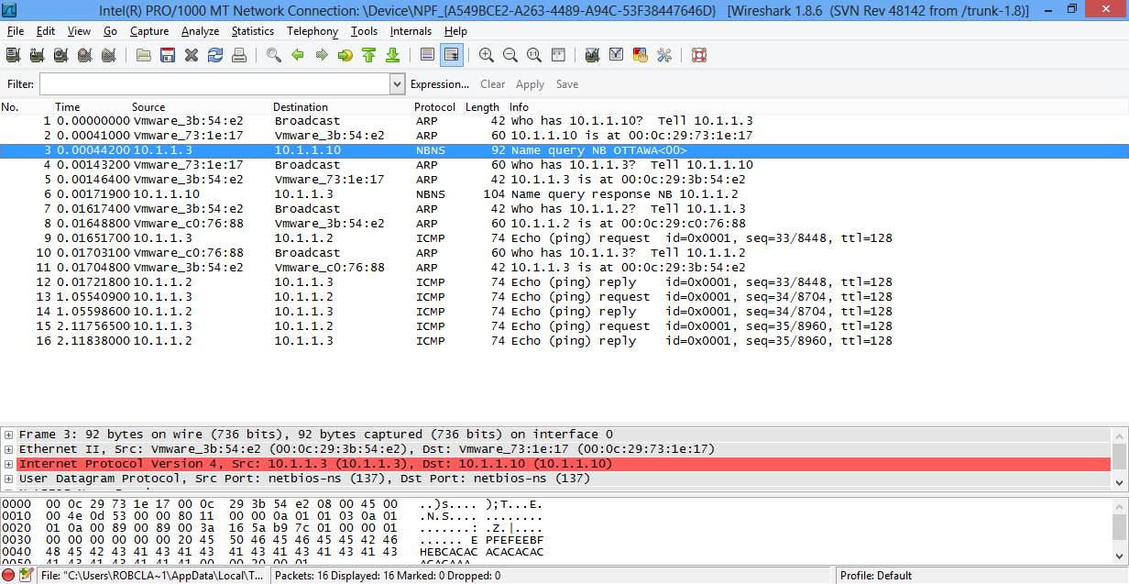

**#9 -** Explain the sequence of events in figure 9. Provide an explanation each of the first 12 frames. Use computer names instead of IP addresses:

Based on the following methods to map a name into an IPv4 address:

**NetBIOS WINS broadcast lmhosts**

**cache server file**

Hamilton CMD: ‘$ ping ottawa’ (Ottawa: 10.1.1.2/xx:xx:88)

Note: since we did nbtstat –RR there is no NetBIOS cache. Any name resolution request will now go to WINS Server (10.1.1.10/CALGARY)

**Frame 1:** 10.1.1.3 (Hamilton) sends an **address resolution request** to everyone on the network (broadcast) asking what MAC address has 10.1.1.10 (our WINS Server)

Frame 2: xx:xx:17 (Calgary) sends an ARP reply to xx:xx:E2 (Hamilton) that   
10.1.1.10 is at MAC address xx:xx:17

Frame 3: 10.1.1.3 (Hamilton) sends **name resolution request** to 10.1.1.10 (Calgary/WINS)

Frame 4: xx:xx:17 (Calgary/WINS) sends an address resolution request to everyone asking

“10.1.1.3, what is your physical address on this network, so I can reply to you”

Frame 5: xx:xx:E2 (Hamilton) replies to xx:xx:17 (Calgary/WINS) “10.1.1.3 belongs to xx:xx:E2”

Frame 6: 10.1.1.10 (Calgary/WINS) says “ok 10.1.1.3 (Hamilton), the name ‘ottawa’ belongs 10.1.1.2”

Frame 7: xx:xx:E2 (Hamilton) asks everyone on the network “ok 10.1.1.2, tell me your physical address so I can talk to you”

Frame 8: xx:xx:88 (Ottawa) says “hey xx:xx:E2 (Hamilton), xx:xx:88 has 10.1.1.2 (Ottawa)”

Frame 9: 10.1.1.3 (Hamilton) sends a ‘ping’ request to 10.1.1.2 (Ottawa) now that he has both the physical address (Layer 2) and ip address (Layer 3).

Frame 10: xx:xx:88 (Ottawa) broadcasts “who on this network has ip 10.1.1.3, what is your physical address so I can send you my reply”

Frame 11: xx:xx:E2 replies “hey xx:xx:88 (Ottawa), 10.1.1.3’s physical address is xx:xx:E2 (Hamilton)”

Frame 12-16: (Ping request is made to Ottawa, Ottawa replies to Hamilton) x3

**#10** - Capture the lmhosts file showing the recorded you added for Japan.